Day 8 – Visiting the local contract office

Congratulations to making to Day #8.

Today we are leaving the house to meet the contract officer representative (COR). First we must identify them, secondly we setup a meeting and then we go and visit them.

Easy enough!

Let me show you how to find them using commonly used everyday websites. Then I’ll show you how to setup a meeting with them.

Lastly we will close with what to say, write and take to the meeting.

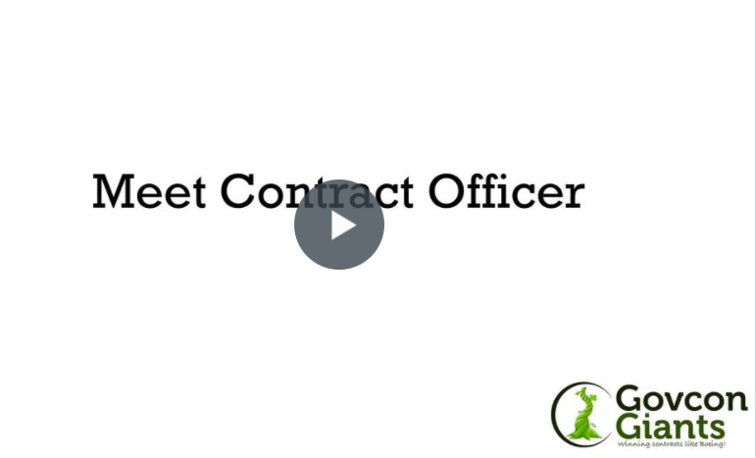

Complete Strategy #4

FYI: The only person that can issue a contract is the contract officer representative on behalf of a contract officer. Thus there is no other way to become a prime contractor unless you get to know who’s handing out the contracts.

Eric Coffie

